**COMMUNICATION SYSTEMS**

#### COMMUNICATION SYSTEMS:

#### Introduction, Elements of Communication system, Modulation- AM, FM (Only concepts, working principle, waveform and Comparison), Super heterodyne receiver, Digital Communication block diagram.

#### INTRODUCTION TO MICROPROCESSOR AND MICROCONTROLLER:

#### Microprocessor, Microcontroller (Only concepts, working principle, and Comparison)

#### Introduction:

#### The Electromagnetic Spectrum

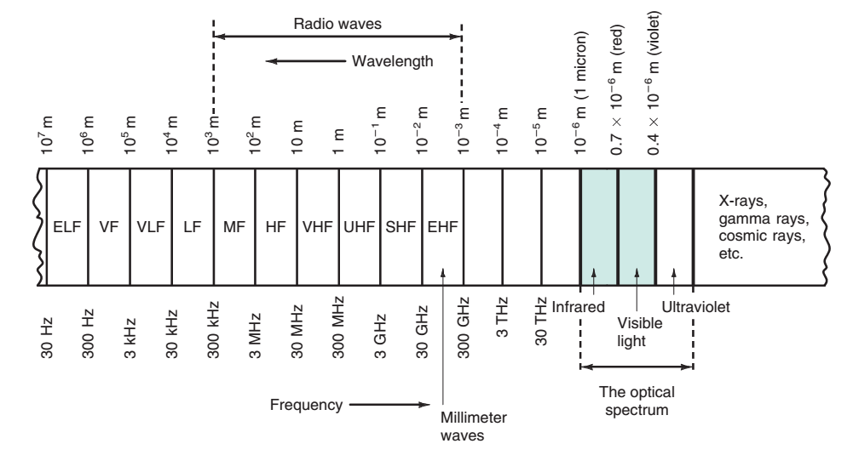

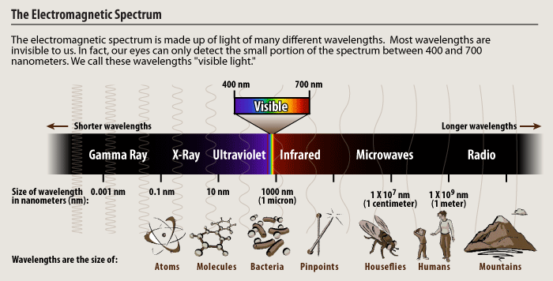Figure 1: The Electromagnetic Spectrum

#### Electromagnetic waves are signals that oscillate; i.e., the amplitudes of the electric and magnetic fields vary at a specific rate. The field intensities fluctuate up and down, and the polarity reverses a given number of times per second. The electromagnetic waves vary sinusoidally. Their frequency is measured in cycles per second (cps) or hertz (Hz). These oscillations may occur at a very low frequency or at an extremely high frequency. The range of electromagnetic signals encompassing all frequencies is referred to as the electromagnetic spectrum.

#### All electrical and electronic signals that radiate into free space fall into the electromagnetic spectrum. Not included are signals carried by cables. Signals carried by cable may share the same frequencies of similar signals in the spectrum, but they are not radio signals. Fig. 1 shows the entire electromagnetic spectrum, giving both frequencies and wavelength. Within the middle ranges are located the most commonly used radio frequencies for two-way communication, TV, cell phones, wireless LANs, radar, and other applications. At the upper end of the spectrum is infrared and visible light. Fig. 2 is a listing of the generally recognized segments in the spectrum used for electronic communication and other applications.

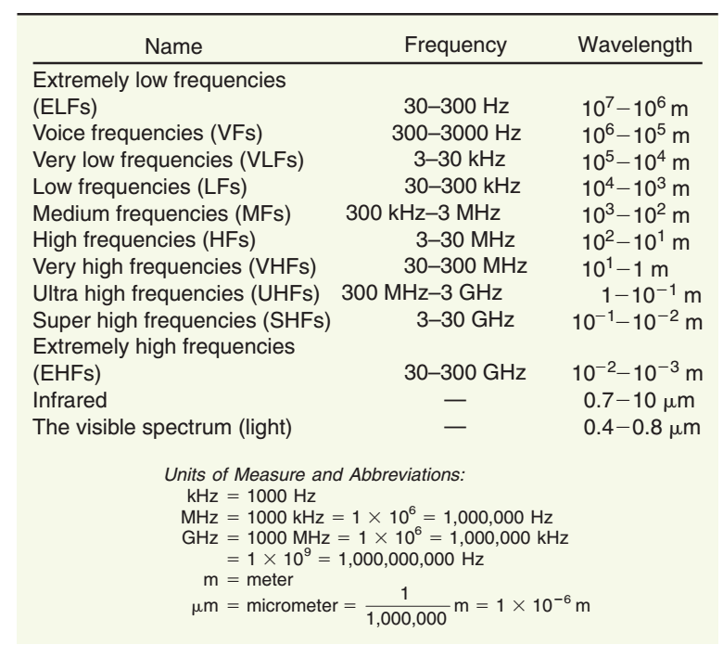

Figure: 2 The Electromagnetic spectrum

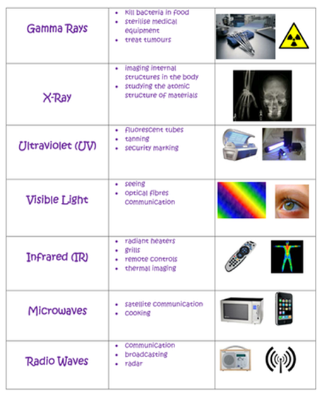

Figure 3: Application of Electromagnetic waves

**General block diagram of a Communication System**

All electronic communication systems have a transmitter, a communication channel or medium, and a receiver. These basic components are shown in Fig. 4. The process of communication begins when a human being generates some kind of message, data, or other intelligence that must be received by others. A message may also be generated by a computer or electronic current. In *electronic communication systems,* the message is referred to as *information,* or an intelligence signal. This message, in the form of an electronic signal, is fed to the transmitter, which then transmits the message over the communication channel. The message is picked up by the receiver and relayed to another human. Along the way, noise is added in the communication channel and in the receiver. *Noise* is the general term applied to any phenomenon that degrades or interferes with the transmitted information.

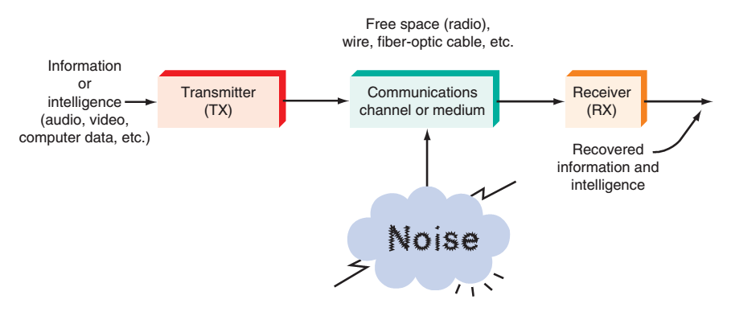

***Fig.4:* General block diagram of all communication system**

**Transmitter**

The first step in sending a message is to convert it into electronic form suitable for transmission. For voice messages, a microphone is used to translate the sound into an electronic *audio* signal. For TV, a camera converts the light information in the scene to a video signal. In computer systems, the message is typed on a keyboard and converted to binary codes that can be stored in memory or transmitted serially. Transducers convert physical characteristics (temperature, pressure, light intensity, and so on) into electrical signals.

The *transmitter* itself is a collection of electronic components and circuits designed to convert the electrical signal to a signal suitable for transmission over a given communication medium. Transmitters are made up of oscillators, amplifiers, tuned circuits and filters, modulators, frequency mixers, frequency synthesizers, and other circuits. The original intelligence signal usually modulates a higher-frequency carrier sine wave generated by the transmitter, and the combination is raised in amplitude by power amplifiers, resulting in a signal that is compatible with the selected transmission medium.

**Communication Channel**

The *communication channel* is the medium by which the electronic signal is sent from one place to another. Many different types of media are used in communication systems, including wire conductors, fiber-optic cable, and free space.

**Receivers**

A *receiver* is a collection of electronic components and circuits that accepts the transmitted message from the channel and converts it back to a form understandable by humans. Receivers contain amplifiers, oscillators, mixers, tuned circuits and filters, and a demodulator or detector that recovers the original intelligence signal from the modulated carrier. The output is the original signal, which is then read out or displayed. It may be a voice signal sent to a speaker, a video signal fed to an LCD screen for display, or binary data received by a computer and then printed out or displayed on a video monitor.

**Attenuation**

Signal *attenuation,* or degradation, is inevitable no matter what the medium of transmission. Attenuation is proportional to the square of the distance between the transmitter and receiver.

Thus considerable signal amplification, in both the transmitter and the receiver, is required for successful transmission.

**Noise**

Noise is mentioned here because it is the bane of all electronic communications. Its effect is experienced in the receiver part of any communications system. While some noise can be filtered out, the general way to minimize noise is to use components that contribute less noise and to lower their temperatures.

### Need for Modulation

1. **Practical Antenna length-**theory shows that in order to transmit a wave effectively the length of the transmitting antenna should be approximately equal to the wavelength of the wave.



The audio frequencies range from 20 Hz to 20Khz, if they are transmitted directly into space, the length of the transmitting antenna required would be extremely large. For example to radiate a frequency of 20 KHz directly into space we would need an antenna length of 3x108 /20x103 ≈ 15,000 meters. This is too long to be constructed practically.

1. **Operating Range:** The higher- frequency signals radiate into space more efficiently than the low frequency signals. The high frequency electromagnetic signals are able to travel through space for long distances, since they undergo less attenuation.
2. **Improves Quality of Reception:** Using modulation techniques like FM, PCM, reduces the effect of noise to great extent. Reduction in noise improves the quality of reception.
3. **Avoids mixing of the signals, allows multiplexing of the signal:** The use of modulation also permits another technique, known as multiplexing, to be used. Multiplexing is the process of allowing two or more signals to share the same medium or channel.

**Significance of Bandwidth**

*Bandwidth (BW)* is that portion of the electromagnetic spectrum occupied by a signal. It is also the frequency range over which a receiver or other electronic circuit operates. More specifically, bandwidth is the difference between the upper and lower frequency limits of the signal or the equipment operation range. Fig. 5 shows the bandwidth of the voice frequency range from 300 to 3000 Hz. The upper frequency is f2 and the lower frequency is f1. The bandwidth, then, is **BW=f2– f1.**

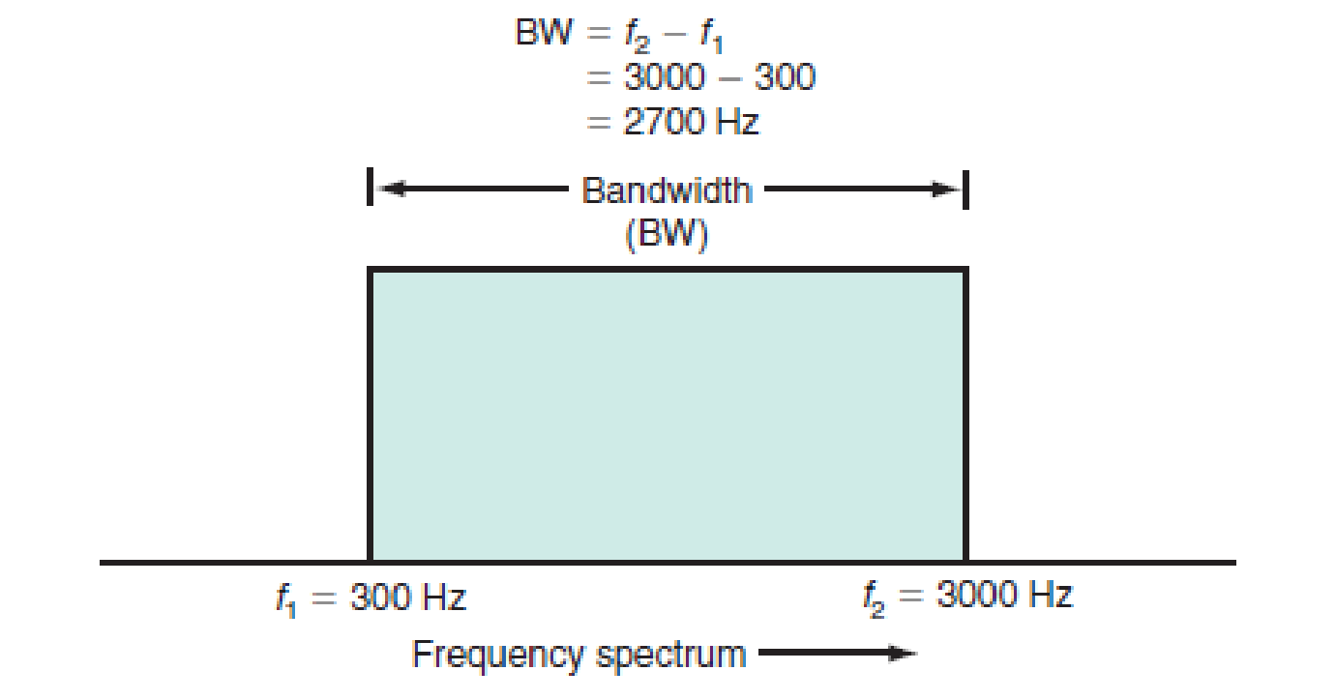

**Fig. 5 voice frequency bandwidth**

**AM and FM Systems**

### Types of modulation-

* 1. Amplitude modulation
  2. Frequency modulation
  3. Phase modulation

The three ways to make the baseband signal change the career sine wave are to vary its amplitude, vary its frequency or vary its phase angle. The two most common methods of modulation are amplitude modulation (AM) and frequency modulation (FM). In AM, the baseband information signal called modulating signal varies the amplitude of the high frequency carrier signal as shown in fig. 6.a. In FM, the information signal varies the frequency of the carrier, as shown in fig. 6.b.

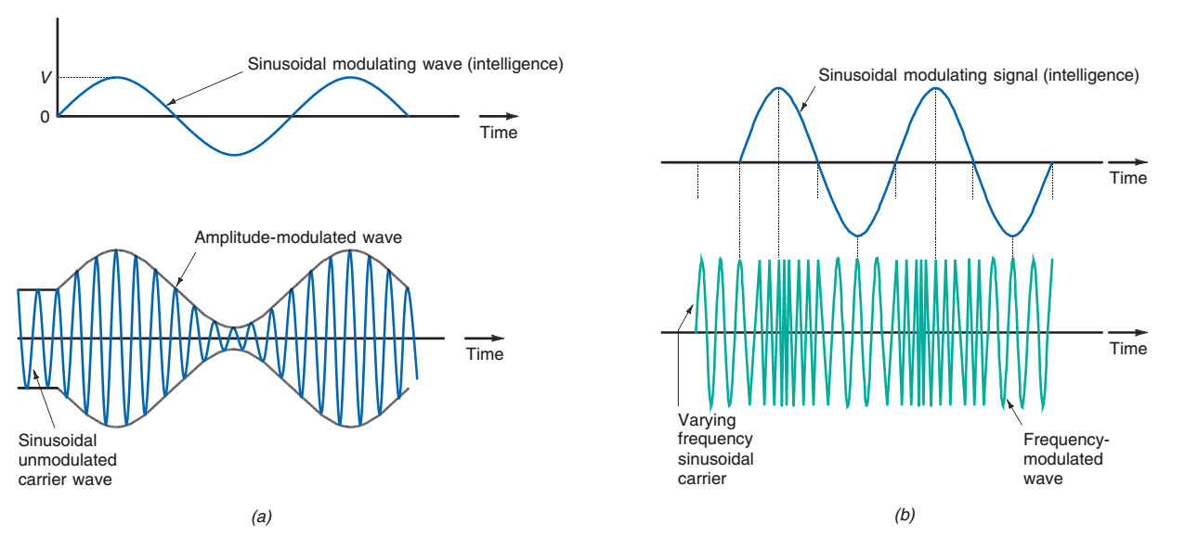

***Fig. 6:* Types of Modulation. a) Amplitude Modulation b) Frequency Modulation**

### Amplitude modulation:

When the amplitude of a high-frequency carrier wave is changed in accordance with the intensity of the signal, it is called amplitude modulation.

The following points are to be noted in amplitude modulation.

* 1. The amplitude of the carrier wave changes according to the instantaneous amplitude of the message signal.
  2. The amplitude variations of the carrier wave are at the signal frequency fm.
  3. The frequency of the amplitude-modulated wave remains the same as the unmodulated carrier frequency fC.



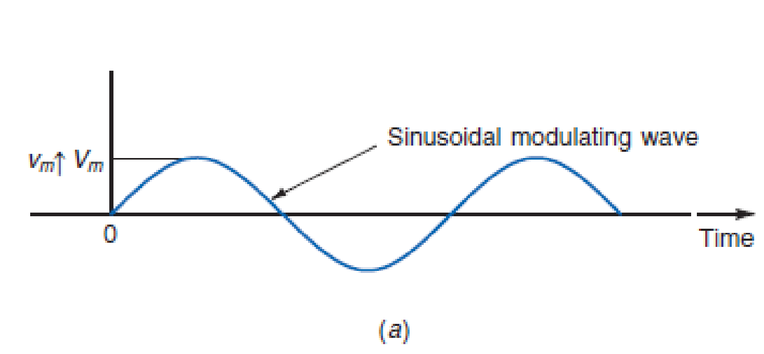

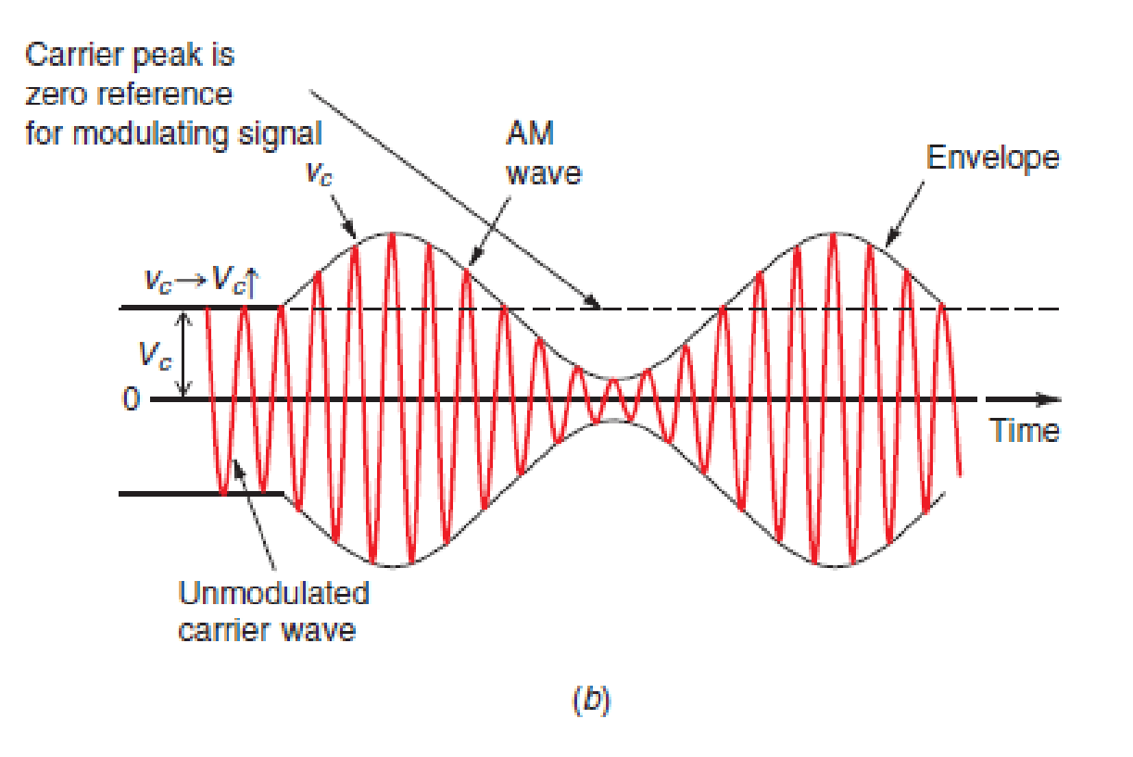

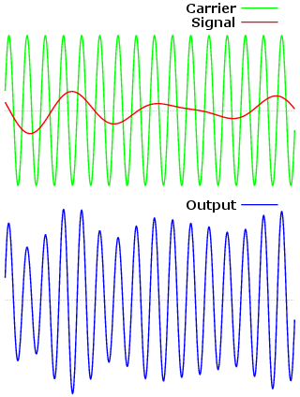

**Fig. 7(c) Modulating signal (Non-sinusoidal / Audio) and modulated carrier**

**AM derivation**

A sine wave carrier signal is of the form and a sine wave message signal is of the form .



Notice that the amplitude of the high frequency carrier takes on the shape of the lower frequency modulation signal forming what is called a modulation envelope.

The modulation index is defined as the ratio of the modulation signal amplitude to the carrier signal amplitude. where . The overall signal can be described by:



A note on frequency multiplication:

The product of two sine waves produces sum and difference frequencies:



As a result, expanding the instantaneous AM expression results in:



From this we observe that upper and lower sidebands are created when using amplitude modulation. The sideband amplitude is: , and the total occupied spectrum is twice the bandwidth of the modulation signal or .



AM signals are often characterized in terms of power, since it is power, which is used to drive antennas. The total power in a 1 Ω resistor is given by:



From this we observe that with a modulation index of 0, the transmitted power is equal to the carrier power. However, when the modulation index is 1, the total transmitted power increases to 1.5 times the carrier power.

**At 100% modulation, only 1/3 of the total power is in the sidebands or only 1/2 of the carrier power is in the sidebands.**

In terms of voltages and currents:



If the carrier is modulated by a complex signal, the effective modulation can be determined by the combining the modulation index of each component.



### Modulation Index

Modulation factor is very important since it determines the strength and quality of the transmitted signal. The greater the degree of modulation, the stronger and clearer will be the audio signal. It should be noted that if the carrier is over modulated (ie m>1) distortion will occur at reception. Typically m lies between 0 and 1.

### Limitations of Amplitude Modulation

1. **Noisy Reception-** In an AM wave, the signal is in the amplitude variations of the carrier. Practically all the natural and man-made noises consist of electrical amplitude disturbances. As a radio receiver cannot distinguish between amplitude variations that represent noise and those that contain the desired signal. Therefore reception is very noisy.
2. **Low efficiency-** In AM useful power is in the sidebands as they contain the signal. An AM wave has low sideband power.

For example even if modulation is 100% ie m=1, the efficiency is 33.33%. Practically efficiency will be lesser than 33.33%.

The carrier itself conveys no information. The carrier can be transmitted and received, but unless modulation occurs, no information will be transmitted. When modulation occurs, sidebands are produced. It is easy to conclude, therefore, that all the transmitted information is contained within the sidebands. Only one-third of the total transmitted power is allotted to the sidebands, and the remaining two-thirds is literally wasted on the carrier.

1. **Lack of audio quality-** The audio signals that are AM modulated has poor audio quality.
2. **Low Spectrum efficiency-** The real information is contained within the sidebands. One way to improve the spectral efficiency of amplitude modulation is to suppress the carrier and eliminate one sideband.

### Frequency modulation:

When the frequency of carrier wave is changed in accordance with the intensity of the signal, it is called frequency modulation.

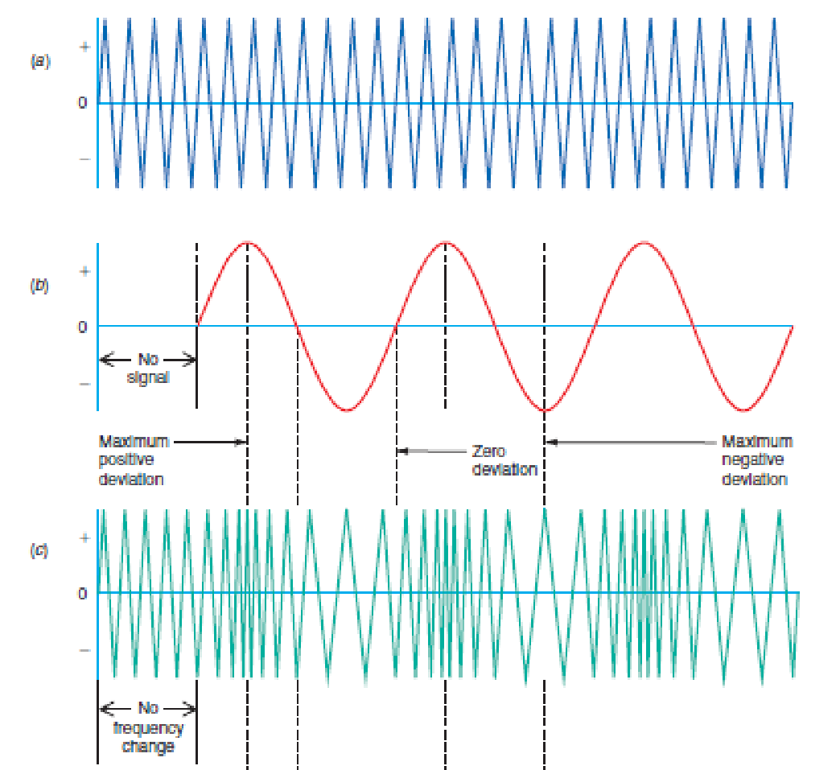

**Fig. 8: Frequency modulation waveforms**

* Here the amplitude of the modulated wave remains the same ie carrier wave amplitude.
* The frequency variations of carrier wave depend upon the instantaneous amplitude of the signal.
* When the signal approaches positive peaks, the carrier frequency is increased to maximum and during negative peak, the carrier frequency is reduced to minimum as shown by widely spaced cycles.

### Advantages of FM

1. It gives noiseless reception.
2. The operating range is quite large.
3. The efficiency of transmission is very high.

**Comparison between Amplitude Modulation and Frequency Modulation**

| **AMPLITUDE MODULATION** | **FREQUENCY MODULATION** |
| --- | --- |
| Amplitude of the carrier varies while its frequency remain constant | Frequency of the carrier varies while its Amplitude remain constant |
| Modulation index can have values from 0 to 1 only | Modulation index is much greater than one |
| AM has only two side bands | FM has infinite side bands |
| BW is twice the highest modulating frequency | BW is much larger than AM |
| Susceptible to noise | More immune to noise |
| Range:  500KHz to 3MHz | Range:  88MHz to 108M Hz |
| AM covers long distances | FM covers short distance |
| Propagation is by ground waves and sky waves | Propagation is by space waves |
| Requires less complex and less expensive equipment | Requires more complex equipment |

**Super Heterodyne Receiver:**

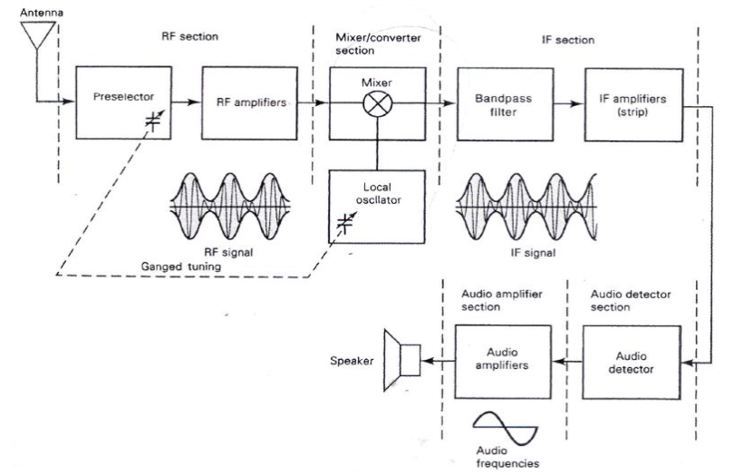

**Fig 8 : Superhetrodyne AM receiver**

The nonuniform selectivity of the TRF led to the development of the superheterodyne receiver near the end of World War I. Although the quality of the superheterodyne receiver has improved greatly since its original design, its basic configuration has not changed much, and it is still used today for a wide variety of radio communications services. The superheterodyne receiver has remained in use because its gain, selectivity, and sensitivity characteristics are superior to those of other receiver configurations. Heterodyne means to mix two frequencies together in a nonlinear device or to translate one frequency to another using nonlinear mixing.

**Heterodyning**

Necessity of heterodyning: Superheterodyne AM receiver works on the principle of heterodyning action.

The necessity of heterodyning action is due to the following reasons.

1. It is difficult to design a RF amplifier with high gain and high band width.

2. It is relatively easier to design a high gain IF amplifier having uniform gain over a narrow band of comparatively lower intermediate frequencies (IF).

3. Hence it is necessary to convert the Radio frequencies to Intermediate Frequencies for efficient processing.

Heterodyning Action: Heterodyning action is a process of combining two ac signals of different frequencies in-order to obtain signals of new frequencies. A circuit called mixer or converter is used for heterodyning two signals. If f1 and f2 are the two frequencies combined, then heterodyning results in two components

1. The sum component with frequency f1+f2 which is filtered out using a bandpass filter.

2. The difference component with frequency f1- f2 is retained and processed.

In case of superheterodyne receiver the RF carrier fc is heterodyned with a higher RF local signal fs (From Local Oscillator or BFO) so that the output difference component (fs- fc) is always of frequency 455kHz.

A block diagram of a noncoherent superheterodyne receiver is shown in Figure.

Essentially, there are five sections to a superheterodyne receiver: the RF section, the mixer/converter section, the IF section audio detector section, and the audio amplifier section.

**RF section:** The RF section generally consists of a preselector and an amplifier stage. They can be separate circuits or a single combined circuit. The preselector is a broad bandpass filter with an adjustable centre frequency that is tuned to the desired carrier frequency The primary purpose of the preselector is to provide enough initial band limiting to prevent unwanted radio frequency, called the image frequency, from entering the receiver (frequency is explained later in this section). The preselector also reduces the noise bandwidth the receiver and provides the initial step toward reducing the overall receiver bandwidth minimum bandwidth required to pass the information signals. The RF amplifier determine sensitivity of the receiver (i.e., sets the signal threshold). Also, because the RF amplifier first active device encountered by a received signal, it is the primary contributor of not therefore, a predominant factor in determining the noise figure for the receiver. A receiver has one or more RF amplifiers, or it may not have any, depending on the desired sensitivity: Several advantages of including RF amplifiers in a receiver are as follows:

1. Greater gain, thus better sensitivity 2. Improved image-frequency rejection 3. Better signal-to-noise ratio 4. Better selectivity

**Mixer/converter Section:** The mixer/converter section includes frequency oscillator stage (commonly called a local oscillator) and a mixer/convert (commonly called the first detector). This stage is a nonlinear device and its purpose is to convert radio frequencies to inters frequencies (RF- to-IF frequency translation). Heterodyning takes place in the mixer and radio frequencies are down- converted to intermediate frequencies. Although the and sideband frequencies are translated from RF to IF, the shape of the envelope the same and, therefore, the original information contained in the envelope remain changed. It is important to note that although the carrier and upper and lower side frequencies change frequency, the bandwidth is unchanged by the heterodyning process. The common intermediate frequency used in AM broadcast-band receivers is 455 kHz

**IF section:** The IF section consists of a series of IF amplifiers and the filters and is often called the IF strip. Most of the receiver gain and selectivity is act the IF section. The IF center frequency and bandwidth are constant for all stations. So that their frequency is less than any of the RF signals to be received. The IF is lower in frequency than the RF because it is easier and less expensive to construct hi stable amplifiers for the low-frequency signals. Also, low-frequency IF amplifiers likely to oscillate than their RF counterparts.

**Detector section:** The purpose of the detector section is to convert signals back to the original source information. The detector is generally called detector or the second detector in a broadcast-band receiver because the inform signals are audio frequencies. The detector can be as simple as a single diode or as a phase-locked loop or balanced demodulator.

**Audio amplifier section:** The audio section comprises several audio amplifiers and one or more speakers. The number of amplifiers used depend audio signal power desired.

**Digital Communication Block diagram:**

The elements which form a digital communication system is represented by the following block diagram for the ease of understanding.

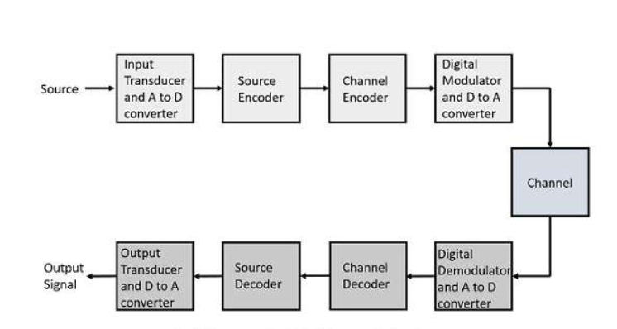

**Fig 9: Elements of digital communication system**

Following are the sections of the digital communication system.

**Source:** The source can be an analog signal. Example: A Sound signal

**Input Transducer:** This is a transducer which takes a physical input and converts it to an electrical signal (Example: microphone). This block also consists of an analog to digital converter where a digital signal is needed for further processes. A digital signal is generally represented by a binary sequence.

**Source Encoder:** The source encoder compresses the data into minimum number of bits. This process helps in effective utilization of the bandwidth. It removes the redundant bits (unnecessary excess bits, i.e., zeroes).

**Channel Encoder:** The channel encoder, does the coding for error correction. During the transmission of the signal, due to the noise in the channel, the signal may get altered and hence to avoid this, the channel encoder adds some redundant bits to the transmitted data. These are the error correcting bits.

**Digital Modulator:** The signal to be transmitted is modulated here by a carrier. The signal is also converted to analog from the digital sequence, in order to make it travel through the channel or medium.

**Channel:** The channel or a medium, allows the analog signal to transmit from the transmitter end to the receiver end.

**Digital Demodulator:** This is the first step at the receiver end. The received signal is demodulated as well as converted again from analog to digital. The signal gets reconstructed here.

**Channel Decoder:** The channel decoder, after detecting the sequence, does some error corrections. The distortions which might occur during the transmission are corrected by adding some redundant bits. This addition of bits helps in the complete recovery of the original signal.

**Source Decoder:** The resultant signal is once again digitized by sampling and quantizing so that the pure digital output is obtained without the loss of information. The source decoder recreates the source output.

**Output Transducer:** This is the last block which converts the signal into the original physical form, which was at the input of the transmitter. It converts the electrical signal into physical output (Example: loud speaker).

**Output Signal:** This is the output which is produced after the whole process. Example − The sound signal received.

**CONTROLLERS**

**Introduction to 8051 Microcontroller**

Microcontroller is a single chip microcomputer which consists of CPU, Memory, I/O ports, timers and other peripherals. The difference between microprocessor and microcontroller is microprocessor is a single integrated CPU whereas microcontroller is single chip microcomputer. The world leaders of manufacturing of microprocessor and microcontroller are Intel, Motorola, IBM, Cyrix etc. In 1981 Intel Corporation introduced an 8 bit microcontroller called 8051.This microcontroller had 128 bytes of RAM, 4K bytes of on-chip ROM, two timers, one serial port and four ports (each 8bit wide) all on a single chip.

**RISC AND CISC CPU ARCHITECTURES**

Microcontrollers with small instruction set are called reduced instruction set computer (RISC) machines and those with complex instruction set are called complex instruction set computer (CISC). Intel 8051 is an example of CISC machine whereas microchip PIC 18F87X is an example of RISC machine.

| **RISC** | **CISC** |
| --- | --- |
| Instruction takes one or two cycles | Instruction takes multiple cycles |
| Only load/store instructions are used to access memory | In addition to load and store instructions, memory access is possible with other instructions also |
| Instructions executed by hardware | Instructions executed by the microprogram |
| Fixed format instruction | Variable format instructions |
| Few addressing modes | Many addressing modes |
| Few instructions | Complex instruction set |
| Most of the have multiple register banks | Single register bank |
| Highly pipelined | Less pipelined |
| Complexity is in the compiler | Complexity in the microprogram |

**HARVARD & VON- NEUMANN CPU ARCHITECTURE**

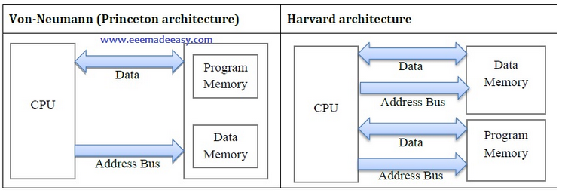

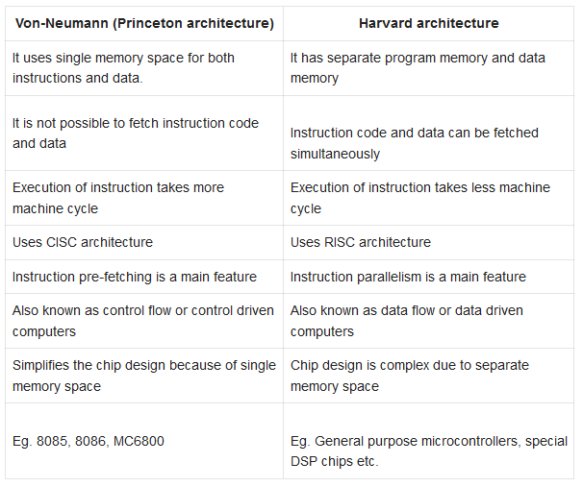

**COMPUTER SOFTWARE**

A set of instructions written in a specific sequence for the computer to solve a specific task is called a program and software is a collection of such programs. The program stored in the computer memory in the form of binary numbers is called machine instructions. The machine language program is called object code. An assembly language is a mnemonic representation of machine language. Machine language and assembly language are low level languages and are processor specific. The assembly language program the programmer enters is called source code. The source code (assembly language) is translated to object code (machine language) using assembler. Programs can be written in high level languages such as C, C++ etc. High level language will be converted to machine language using compiler or interpreter. Compiler reads the entire program and translate into the object code and then it is executed by the processor. Interpreter takes one statement of the high level language as input and translate it into object code and then executes.

**THE 8051 ARCHITECTURE**

Salient features of 8051 microcontroller are given below.

• Eight bit CPU

• On chip clock oscillator

• 4Kbytes of internal program memory (code memory) [ROM]

• 128 bytes of internal data memory [RAM]

• 64 Kbytes of external program memory address space.

• 64 Kbytes of external data memory address space.

• 32 bi directional I/O lines (can be used as four 8 bit ports or 32 individually addressable I/O lines)

• Two 16 Bit Timer/Counter :T0, T1

• Full Duplex serial data receiver/transmitter

• Four Register banks with 8 registers in each bank.

• Sixteen bit Program counter (PC) and a data pointer (DPTR)

• 8 Bit Program Status Word (PSW)

• 8 Bit Stack Pointer

• Five vector interrupt structure (RESET not considered as an interrupt.)

• 8051 CPU consists of 8 bit ALU with associated registers like accumulator ‘A’ , B register,

PSW, SP, 16 bit program counter, stack pointer.

• ALU can perform arithmetic and logic functions on 8 bit variables.

• 8051 has 128 bytes of internal RAM which is divided into

o Working registers [00 – 1F]

o Bit addressable memory area [20 – 2F]

o General purpose memory area (Scratch pad memory) [30-7F]

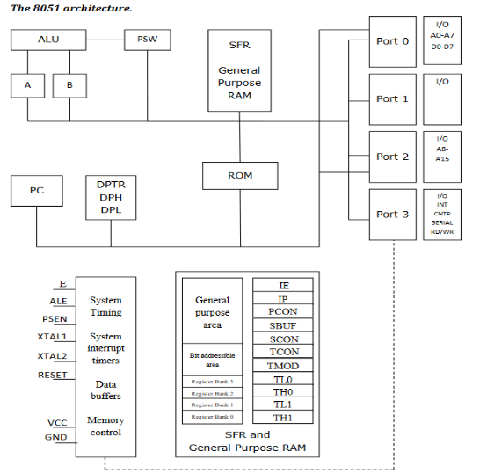

• 8051 has 4 K Bytes of internal ROM. The address space is from 0000 to 0FFFh. If the program size is more than 4 K Bytes 8051 will fetch the code automatically from external memory.

• Accumulator is an 8 bit register widely used for all arithmetic and logical operations. Accumulator is also used to transfer data between external memory. B register is used along with Accumulator for multiplication and division. A and B registers together is also called MATH registers.

• PSW (Program Status Word). This is an 8 bit register which contains the arithmetic status of ALU and the bank select bits of register banks.



CY - carry flag

AC - auxiliary carry flag

F0 - available to the user for general purpose

RS1,RS0 - register bank select bits

OV - overflow

P – parity

• Stack Pointer (SP) – it contains the address of the data item on the top of the stack. Stack may reside anywhere on the internal RAM. On reset, SP is initialized to 07 so that the default stack will start from address 08 onwards.

• Data Pointer (DPTR) – DPH (Data pointer higher byte), DPL (Data pointer lower byte). This is a 16 bit register which is used to furnish address information for internal and external program memory and for external data memory.

• Program Counter (PC) – 16 bit PC contains the address of next instruction to be executed. On reset PC will set to 0000. After fetching every instruction PC will increment by one.

**Parallel and Serial Interfaces:**

The main difference between the serial and parallel interfaces is how they transmit data. In serial interface the data is sent or received one bit at a time over a series of clock pulses. In parallel mode the interface sends and receives 4 bits, 8 bits, or 16 bits of data at a time over multiple transmission lines.

These two interface modes is as given below.

